**Jenkins Task-2**

**Task Description:**

Create a simple script file and push it to repo. Create a project in Jenkins connected to your GitHub repository. When a commit is made to your repo, automatically build must get triggered from Jenkins and the output must be shared to me via email.

**Techstacks needs to be used :**

* AWS EC2
* Github
* Jenkins

**Installed and Setup Jenkins on EC2:-**

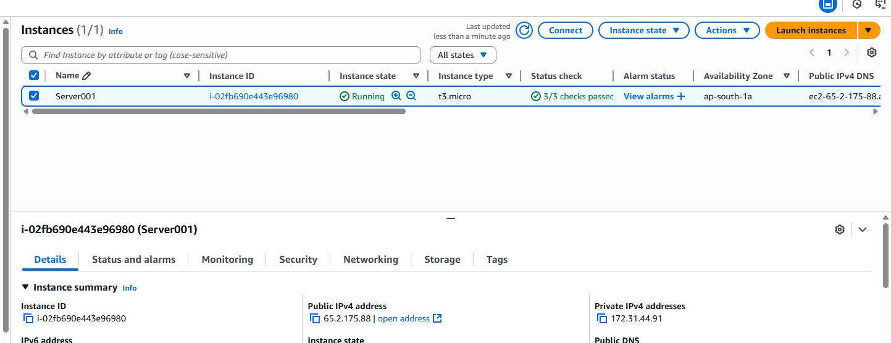  
  
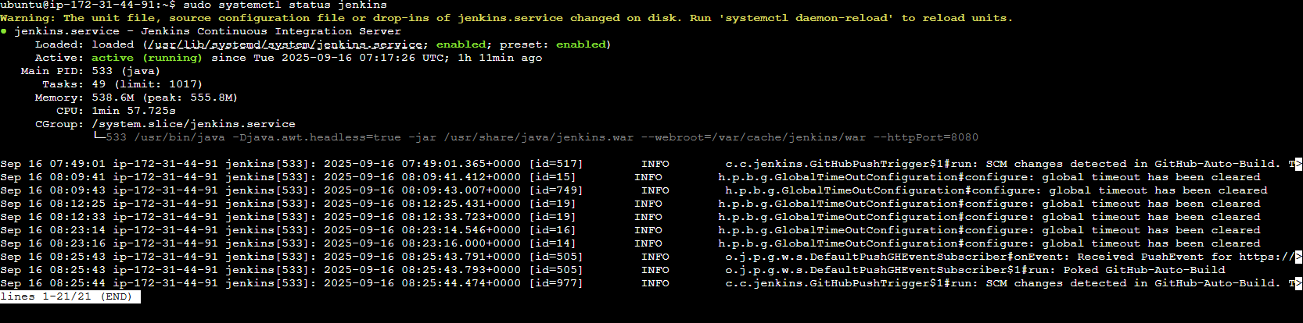  
  
**Access Jenkins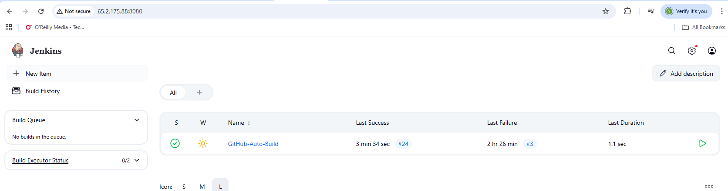 Connect Jenkins with GitHub (Webhook)**  
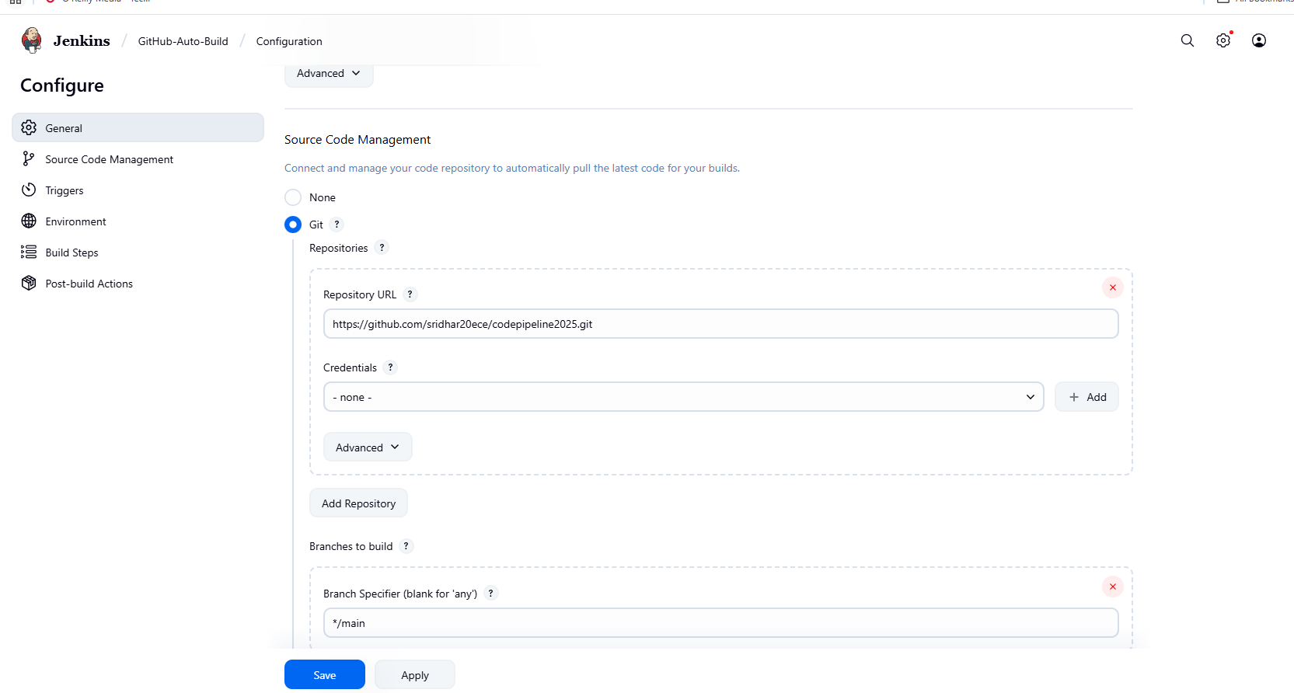  
  
  
**Configure GitHub Webhook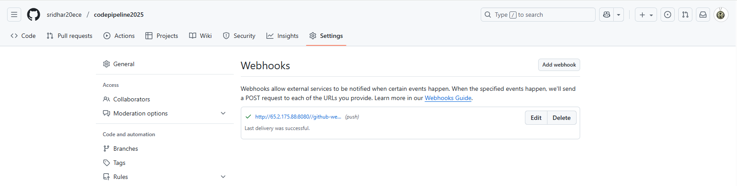 Configure Email Notification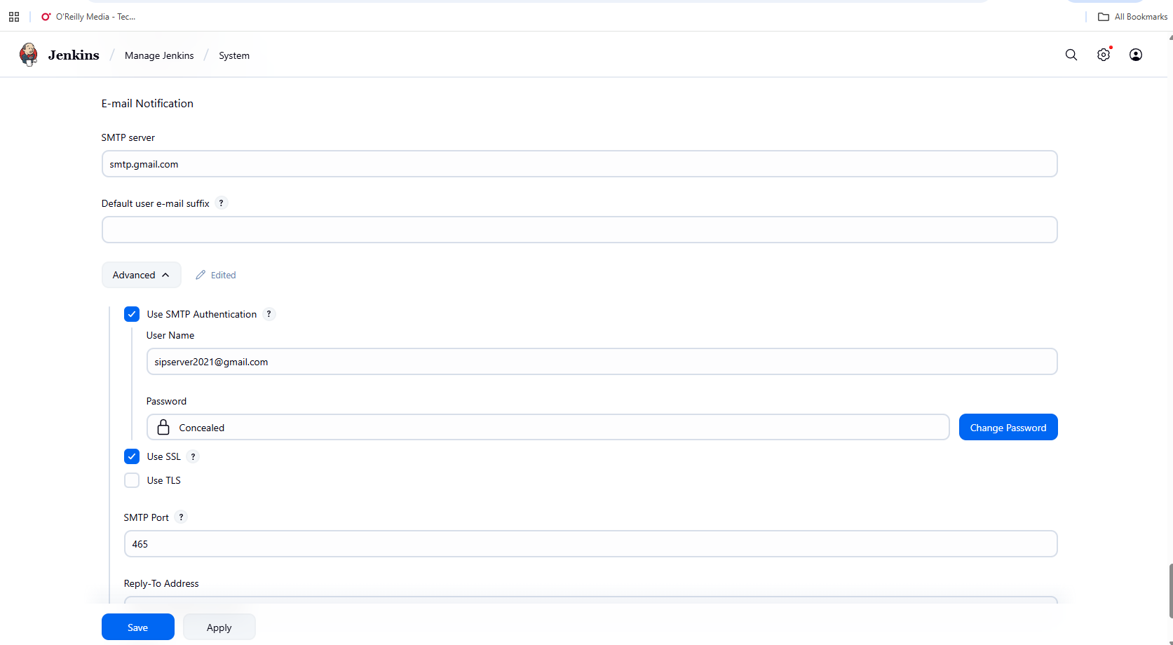 Pushing to git repository: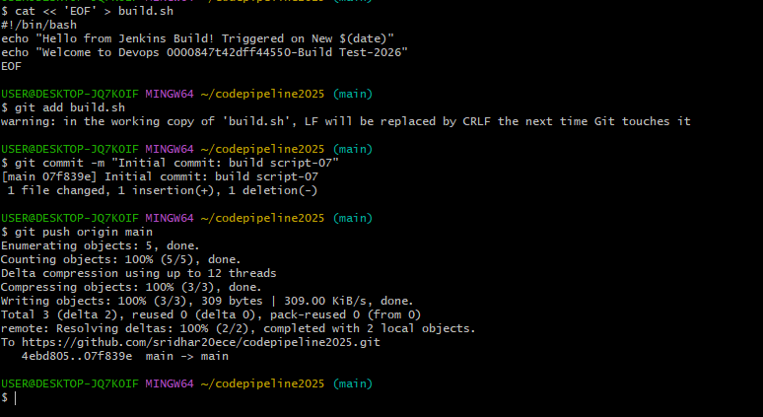 Jenkins Build Job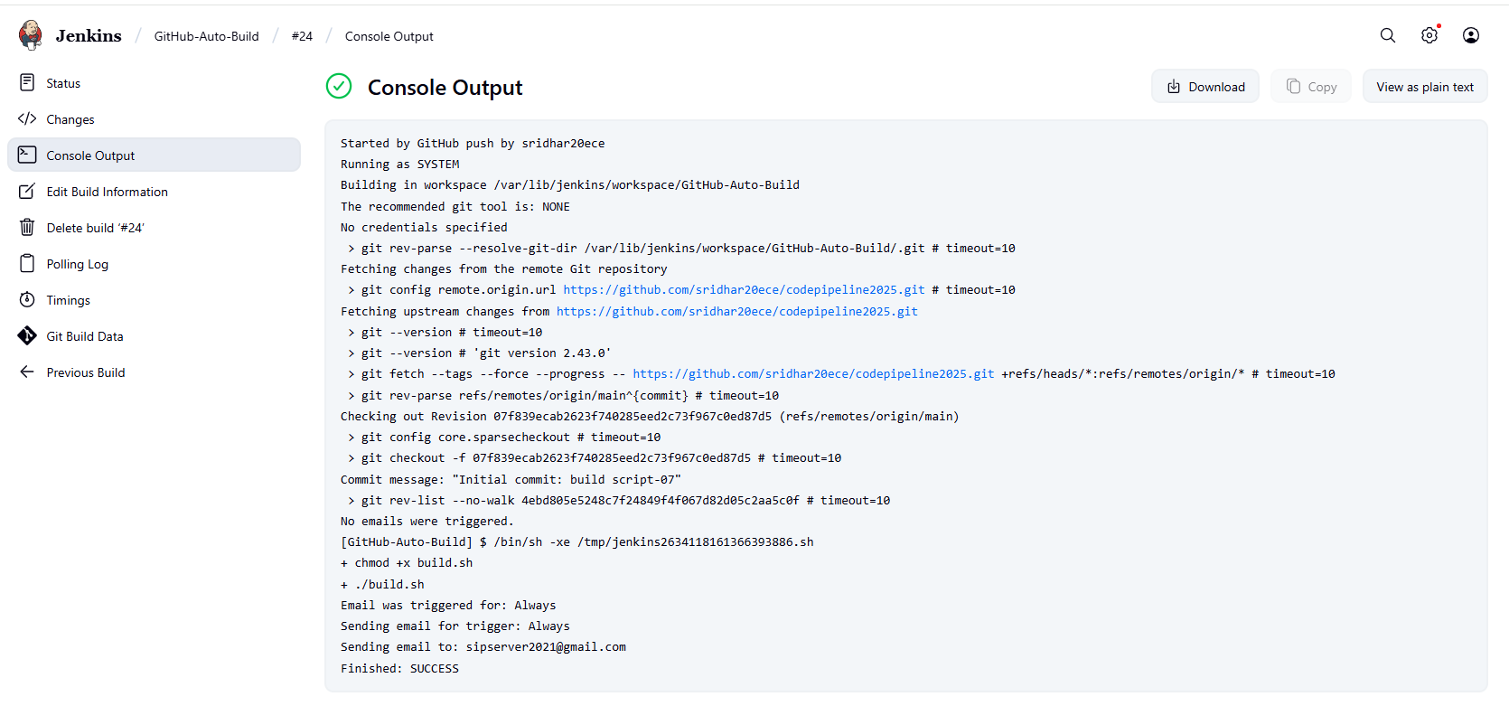 Email Notification:**